Name: Brian Johnston

Student ID: 2019405

Class: COP2362

I worked alone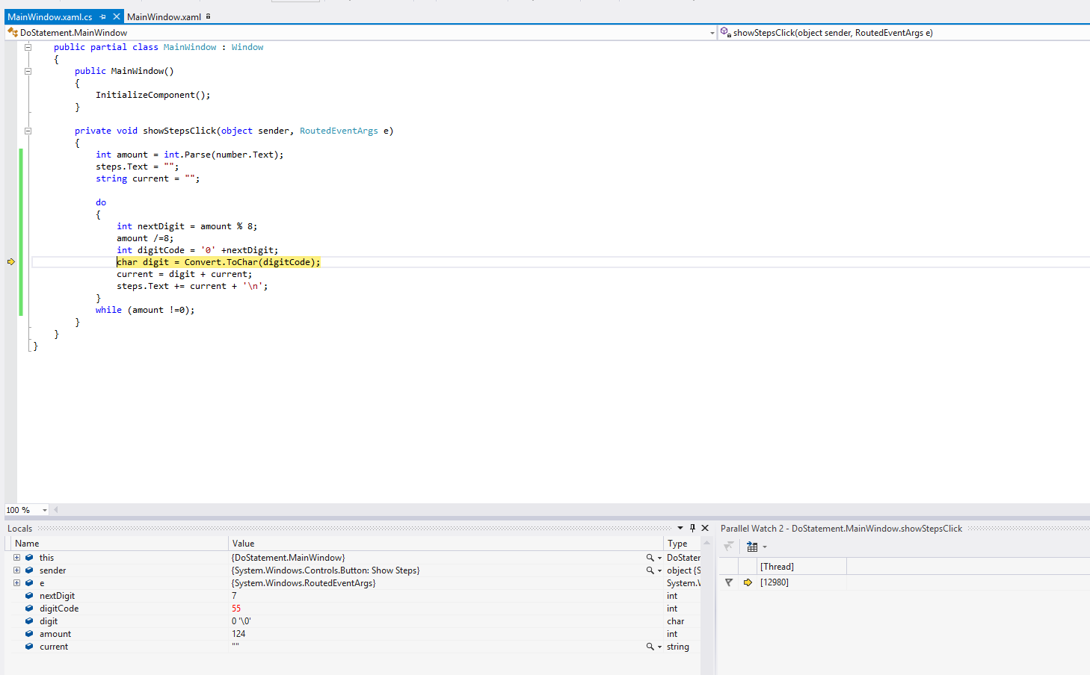

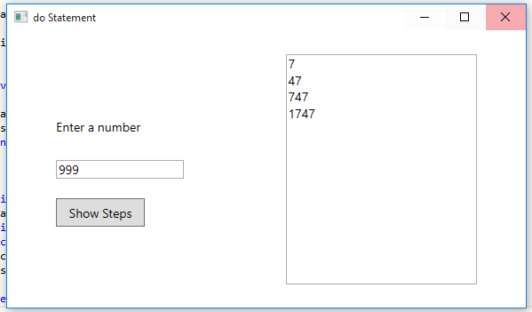

Code:

MainWindow.xaml.cs

using System;

using System.Collections.Generic;

using System.Linq;

using System.Text;

using System.Threading.Tasks;

using System.Windows;

using System.Windows.Controls;

using System.Windows.Data;

using System.Windows.Documents;

using System.Windows.Input;

using System.Windows.Media;

using System.Windows.Media.Imaging;

using System.Windows.Navigation;

using System.Windows.Shapes;

namespace DoStatement

{

/// <summary>

/// Interaction logic for MainWindow.xaml

/// </summary>

public partial class MainWindow : Window

{

public MainWindow()

{

InitializeComponent();

}

private void showStepsClick(object sender, RoutedEventArgs e)

{

int amount = int.Parse(number.Text);

steps.Text = "";

string current = "";

do

{

int nextDigit = amount % 8;

amount /=8;

int digitCode = '0' +nextDigit;

char digit = Convert.ToChar(digitCode);

current = digit + current;

steps.Text += current + '\n';

}

while (amount !=0);

}

}

}

XAML:

<Window x:Class="DoStatement.MainWindow"

xmlns="http://schemas.microsoft.com/winfx/2006/xaml/presentation"

xmlns:x="http://schemas.microsoft.com/winfx/2006/xaml"

Title="do Statement" Height="350" Width="600">

<Grid>

<Grid Margin="12,0,12,0">

<Grid.RowDefinitions>

<RowDefinition Height="\*"/>

<RowDefinition Height="10\*"/>

<RowDefinition Height="\*"/>

</Grid.RowDefinitions>

<Grid.ColumnDefinitions>

<ColumnDefinition Width="\*"/>

<ColumnDefinition Width="5\*"/>

<ColumnDefinition Width="\*"/>

<ColumnDefinition Width="5\*"/>

<ColumnDefinition Width="\*"/>

</Grid.ColumnDefinitions>

<Grid Grid.Row="1" Grid.Column="1">

<Grid.RowDefinitions>

<RowDefinition Height="2\*"/>

<RowDefinition Height="\*"/>

<RowDefinition Height="2\*"/>

<RowDefinition Height="\*"/>

<RowDefinition Height="2\*"/>

</Grid.RowDefinitions>

<TextBlock Grid.Row="1" HorizontalAlignment="Left" VerticalAlignment="Center" FontSize="14" Text="Enter a number" />

<Grid Grid.Row="2">

<Grid.ColumnDefinitions>

<ColumnDefinition Width="2\*" />

<ColumnDefinition Width="\*" />

</Grid.ColumnDefinitions>

<TextBox x:Name="number" Grid.Row="2" HorizontalAlignment="Stretch" VerticalAlignment="Center" FontSize="14" />

</Grid>

<Button x:Name="showSteps" Grid.Row="3" HorizontalAlignment="Left" FontSize="14" Content="Show Steps" Width="100" Click="showStepsClick"/>

</Grid>

<TextBox x:Name="steps" Grid.Column="3" Grid.Row="1" IsReadOnly="True" TextWrapping="Wrap" AcceptsReturn="True" FontSize="14" ScrollViewer.VerticalScrollBarVisibility="Auto" ScrollViewer.HorizontalScrollBarVisibility="Auto"/>

</Grid>

</Grid>

</Window>